**Earthquake Rescue Information System**

**A software Development Project Management report submitted**

**By**

***Zaman Md Sumsush (14-27822-3)***

***Afrin, Ahona (14-26639-2)***

***Hasnat, Ridwan Bin (14-27264-2)***

***Sharmin, Tamanna (13-24709-2)***

***Khan, Akram (13-24767-2)***

**Under the supervision of**

***MOHAMMAD MAHMUDUL HASAN***

***Lecturer***

**Department of Computer Science**

**Faculty of Science & Information Technology**

**American International University – Bangladesh**

**Spring16_17**

**Software Project Management Plan**

**for**

**Earthquake Rescue System**

**Version 1.0 approved**

**Prepared by**

***Zaman Md Sumsush (14-27822-3)***

***Afrin, Ahona (14-26639-2)***

***Hasnat, Ridwan Bin (14-27264-2)***

***Khan, Akram (13-24767-2)***

***Sharmin, Tamanna (13-24709-2)***

**American International University-Bangladesh (AIUB)**

**09.03.2017**

**Table of Contents**

|  |
| --- |
| **Table of Contents………………………………………………………………………… ii**  **Revision History………………………………………………………………………… ii**  **1. Introduction…………………………………………………………………...…...4**  **1.1 Project  Overview……………………………………………………………...……1**  **1.2 User Scenario……………………………………………………………………… 1**  **1.3 UML………………………………………………………………………………...1**  **1.4 Project Deliverable………………………………………………………………….1**  **2. Project Organization………………………………………………………………2**  **2.1 Work Break Structure……………………………………………………………….2**  **2.2 Activity Plan………………………………………………………………………...2**  **2.3 Effort Estimation Plan ………………………………………………………………2**  **2.4 Risk Management Plan……………………………………………………………...2**  **2.5 Resource Allocation………………………………………………………………...2** |

**Revision History**

|  |  |  |  |
| --- | --- | --- | --- |
| **Revision** | **Date** | **Updated By** | **Update Comments** |
| 0.1 | 09.03.2017 | Zaman Md Sumsush | 1st Draft |
| 0.2 | 10.03.2017 | Hasnat, Ridwan Bin | 2nd Draft |
| 0.3 | 10.03.2017 | Afrin, Ahona | 3rd Draft |
| 0.4 | 11.03.2017 | Zaman Md Sumsush | 4th Draft |
| 0.5 | 11.03.2.17 | Afrin, Ahona | 5th Draft |
| 0.6 | 11.03.2017 | Khan, Akram | 6th Draft |
| 0.7 | 11.03.2017 | Sharmin, Tamanna | 7th Draft |
| 0.8 | 11.03.2017 | Zaman Md Sumsush | 8th Draft |
| 0.9 | 27.04.2017 | Hasnat, Ridwan Bin | 9ht Draft |
| 0.10 | 30.04.2017 | Afrin, Ahona | 10ht Draft |
| 0.11 | 01.05.2017 | Khan, Akram | 11ht Draft |
| 0.12 | 02.05.2017 | Sharmin, Tamanna | 12ht Draft |
| 0.13 | 02.05.2017 | Zaman Md Sumsush | 13ht Draft |

**1.Introduction**

The purpose of This document describes the statement of work (SOW) for developing an automated system for earthquake rescue team to identify the possible position of victim human body from the wreckage of destroyed building. This particular documented (SOW) is intended for the further development of a fully functional earthquake rescue information system.This document also provides the vendors with the relevant t technical, performance, application, and architectural requirements of the system along with it’s deliverables. This also contains a brief analysis costing of the project ,the possible risk that might the developers face

During the development period and it’s ultimate quality goals.

**1.1 Project Overview**

The number of earthquakes taking place have significantly increased in recent times. Many lives are lost due to the aftermath of this calamitous natural disaster. Most of the lives lost are due to getting trapped under the debris caused by destroyed buildings. Alot more lives are lost due to the lack of knowledge of where the victims might be within all the debris. Since rescuers usually do not know where victims are stuck they stay trapped and eventually die. This is a serious matter at hand as human lives are directly involved and through this project we can help bring improvements into the whole rescuing system and eventually may help save a few extra lives. This software will help determine an estimated location of the trapped victims with the help of infrared scanners, 3d scanners and a database to store all the information collected from the sensors.

The 3-D scanner will take a 3D view of the entire building and store it in the database. There will be 5 Infrared scanners , 4 on each corner and 1 on the rooftop which will detect the position of anything that is emitting heat from within the building. Deriving from the shape of the source of the thermal body we can determine if it’s coming from a human or not. The database will be updated in an interval of 10-15 mins which would show us the positions of the thermal emitting bodies within the building after being merged with the 3D view of the building collected from the 3D scanners. If and when the building collapses due to an earthquake, the rescue team or the fire brigade can access the database from a central station (there will be one for each area) and collect the latest updated data of the particular building and can find out where the victims were last located within the building before the building had collapsed. Using these information an estimated location of the victims can be determined and the rescuers will set high priority on these locations.

No such software has been developed previously for such purpose and so the cost requirement for this particular software is considered to be minimum. Taking this into consideration the software has high feasibility to meet the business objective.

**1.2 User Scenario**

|  |  |  |
| --- | --- | --- |
| Use-case | Actor | Corresponding user scenario |
| Registration | New User | As a new user, to login into the software, i must first register with proper verification and once authorized I may log into the system. |
| Log in | Owner/Old User | After registering with proper information and verification an user can log in to gain access to a few features. |
| Access 3D view | Owner/Old User | Post login user can check the 3D view of their homes collected from the 3D scanners. (They cannot make any changes to the view- admin privilege only) |
| Access Infrared View | Owner/Old User | User can also access the Infra-red view and check where everyone within the building is present via thermal detection. |
| Sound Alarm (Emergency only) | Owner/Old User | User can logout of their accounts (only in case of major emergencies, otherwise logging out is strictly forbidden) which will sound an alarm to the admins. |
| All | Admin User | Admins will have unique identifiers governed to them by the government. They can access and edit any feature within the software e.g: edit 3D view, edit Infrared view, add/delete user and user registration verification. |

**1.3 UML**

**Usecase**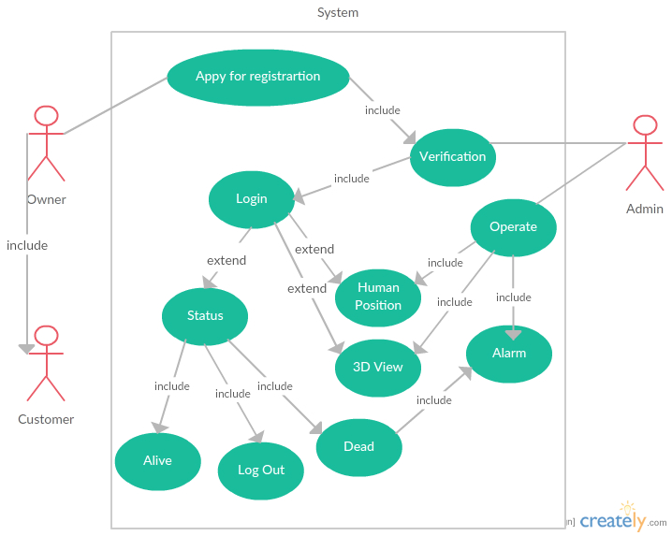

**Class Diagram**

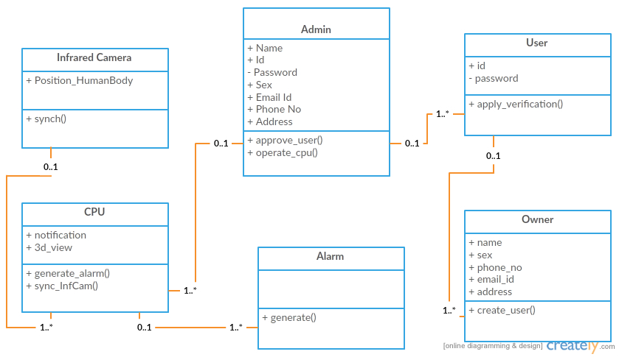  
**Entity Relationship Diagram**

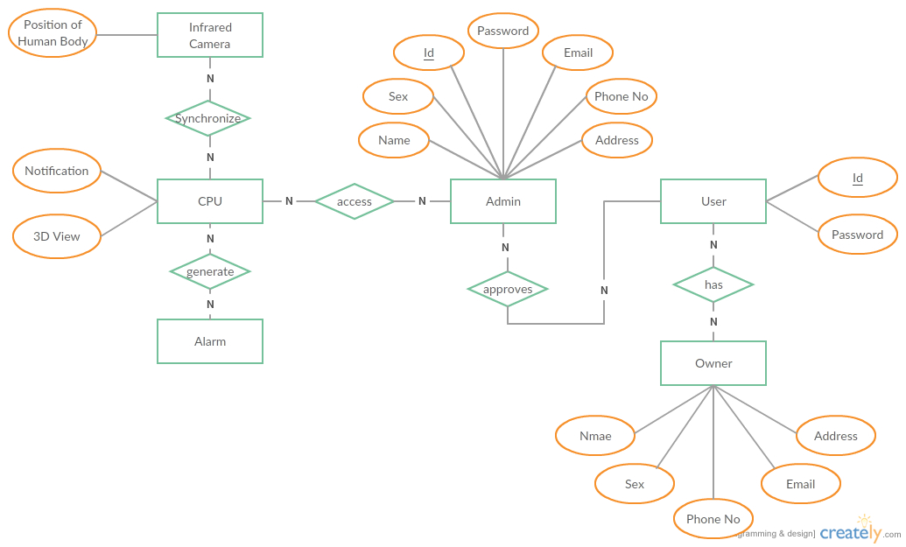

**Activity Diagram**

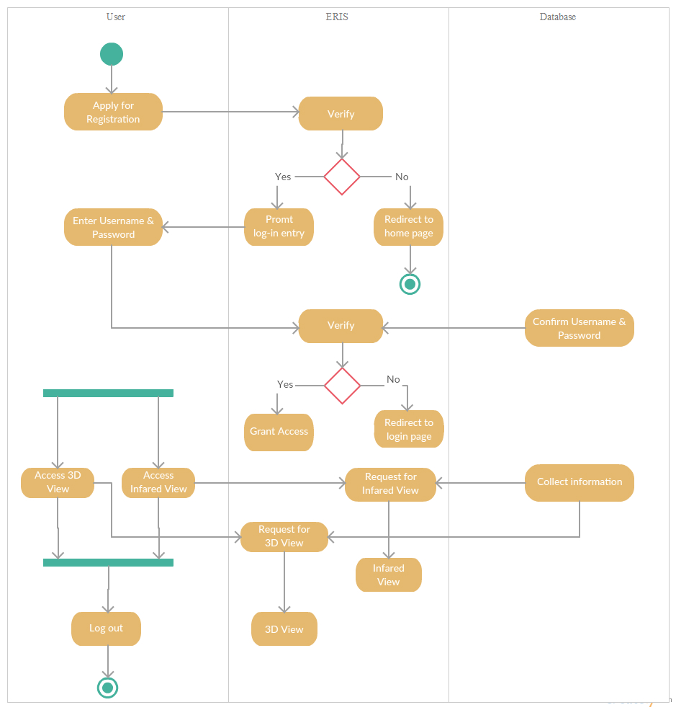

**Work Breakdown Structure**

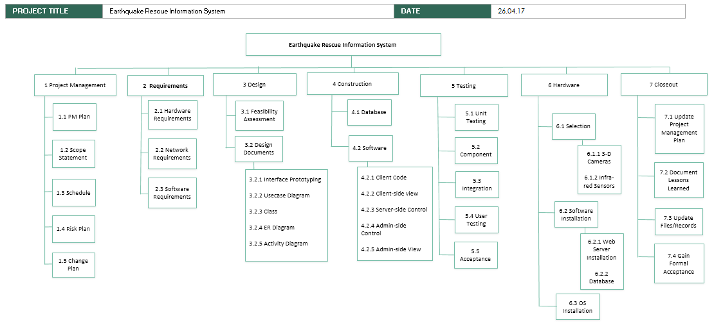

**Activity Plan**

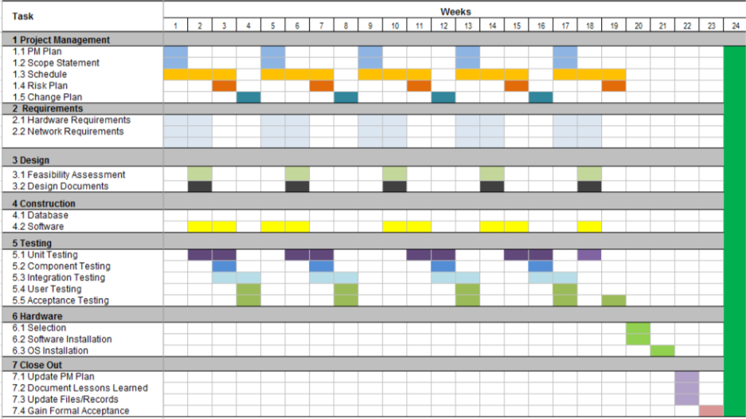

**NETWORK DIAGRAM**



**Effort Estimation**

**COCOMO (Constructive Cost Model):**

Effort = PM = Coefficient<Effort Factor>*(SLOC/1000) ^P

Development time = DM = 2.50*(PM)^T

Required number of people = ST = PM/DM

|  |  |  |  |
| --- | --- | --- | --- |
| Software Project Type | Coefficient<Effort Factor> | P | T |
| Organic | 2.2 | 1.04 | 0.38 |
| Semi-detached | 2.8 | 1.14 | 0.35 |
| Embedded | 3.4 | 1.23 | 0.33 |

PM: person-months needed for project

SLOC: source lines of code

P: project complexity (1.04-1.24)

DM: duration time in months for project

T : SLOC-dependent coefficient (0.32-0.38)

ST : average staffing necessary

SLOC= 20000

As our team member is mixed experience levels works in a mix hardware and software application, we use “Semi-detached project”. For Semidetached project,

Effort = PM = Coefficient<Effort Factor>*(SLOC/1000)^P

                    =2.4*(20000/1000)^1.05

                    = ~ 85.18

Development time = DM = 2.50*(PM)^T

                                        = 2.50 * (85018)^0.38

                                             =  ~ 11.85

Required number of people = ST = PM/DM = 85.18/11.85=7.18

**Resource Allocation**

        The quality of this project can be improved by an effective use of the available technical resources. Because time, quality, quantity of the resources are limiting factor so we have to allocate all of the resource very consciously. All the required resources are identified in the project development. So first we have to identify the types or categories the resources and the resources are allocated in an effective manner with different ways.

**Resources:**

        Member of control the project

        Infrared camera

        Censor

        3-D scanner

        Database

        Device

        Electricity

  Member of control the project are labor categories resource such as project manager, system analysis.

  Infrared camera, sensor, device, electricity and 3-D scanner are equipment categories resource.

  Database is a material categories resource.

  Specialist of the project gives service so it is a service categories resource.

  To monitoring all of those resources money will be needed. It's a secondary resource.

        First indicate the planned start and completion dates for each activity. Then indicate the dates when resources will be required and the level of required resources. And last show the planned accumulative expenditure incurred by the use of resources over time.

        3-D scanner, sensor Infrared camera should be automated, when it is needed exactly that time those things should be on the times it should be in sleeping mode, so it consume the cost of electricity .

        For this project the selection of motivated individuals must also take account of the final shape of the project team and the way they will work together. So make a team building and also allocate junior staff to appropriate non-critical activities where there will be sufficient slack for them to train and develop skills. There can be direct benefits to the particular project since some costs may be allocated to the training budget.

**GanttChart**

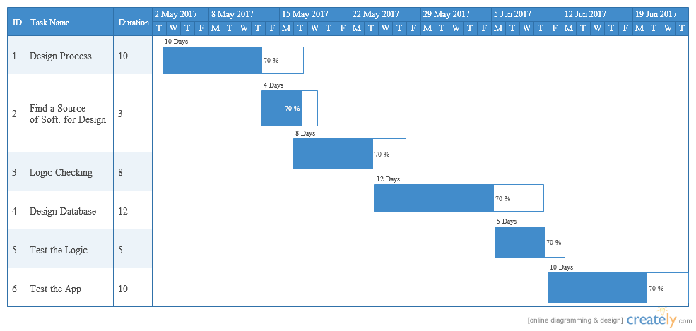

**Risk Analysis:**

 Product size (PS)

 Business impact (BU)

Customer characteristics (CU)

Process definition (PR)  
  
 Development Environment (DE)  
Technology to be built (TE)  
Staff size and experience (ST)

RMMM = Risk Mitigation, Monitoring and Management Plan

**Impact values**

·         Catastrophic = 1

·         Critical = 2

·         Marginal = 3

·         Negligible = 4

**Risk Table**

|  |  |  |  |  |
| --- | --- | --- | --- | --- |
| Risks | Category | Probability | Impact | RMMM |
| 1. Failure of determining the estimated location by infrared scanners | PS | 10% | 3 | More logical and new mechanism may keep it flawless |
| 2. Failure of 3D scanner  connectivity with database  systems | PS | 20% | 4 | Data will be stored in the user device. |
| 3. Lack of access to funding. | CU | 25% | 1 | Aims to secure funding for project before deadline. |
| 4. Limited manpower to complete the project before deadline. | ST | 30% | 1 | Give attention about work distribution. |
| 5. Bugs in development tools. | DE | 28% | 3 | Implement robust preventive maintenance plans. |
| 6. Delivery deadline will be tightened | BU | 50% | 1 | Develop early delivery schedule. |
| 7. Staff inexperienced | ST | 35% | 3 | Train up by old staff |
| 8. Release of more improved technology. | TE | 45% | 4 | Software does have scopes to adapt new technology following certain protocols. |

**ACKNOWLEDGEMENT**

At the End of the project,   we want to give thanks to our respected Faculty MD. Mahmudul Hasan  sir. Also want to give thanks to my entire group members.